


Between Head and Heart
Exploring interception on a cortical and subcortical basis

Master Thesis
Master Cognitive Neuroscience Berlin (MCNB)

Department of Psychology and Education
Freie Universität Berlin

by
Lisa Sophie Paulsen
Mat-Nr: 5574504

Supervisors
Prof. Dr. Huiling Tan
University of Oxford

Prof. Dr. Felix Blankenburg
Freie Universität Berlin

Berlin, DATUM
Master’s Thesis Declaration

For the Master’s Degree Program in Cognitive Neuroscience at the Department of Education and Psychology, Freie Universität Berlin

Herewith I affirm that I wrote the work in hand autonomously and never used another source or resource as declared

___________________________________________________________
Student Location, Date

Abstract

Acknowledgements

Table of Contents
1. Introduction 7
1.1. Measuring the heart-brain interaction 9
1.2. Source Dynamics of the HEP 11
1.3. Recordings 13
1.4. Aim of the project 14
2. Methods 16
2.1. Patients and surgery 16
2.2. Data Recording 17
2.3. Study Design 18
2.4. Signal preprocessing 18
2.4.1. Electrocardiogram (ECG) 19
2.4.2. Electroencephalography (EEG) and local field potential (LFP) 20
2.5. Analysis and Statistics 22
2.5.1. HRV, HR, IBI Analysis 22
2.5.2. HEP Analysis 24
2.5.3. ITC Analysis 25
2.5.4. PSI/CCC Analysis 26
3. Results 28
3.1. ECG features show no modulation by medication 28
3.2. HEP Results 30
3.3. ITC Results 36
3.4. PSI/CCC Results 40
4. Discussion 42
5. References 43
6. Appendix 51

Introduction

Parkinson’s Disease (PD)
Subthalamic Nucleus (STN)
Deep Brain Stimulation (DBS)
Local Field Potential (LFP)
Electroencephalography (EEG)
Electrocardiogram (ECG)
Inter-beat Interval (IBI)
Heartrate (HR)
Heartrate Variability (HRV)

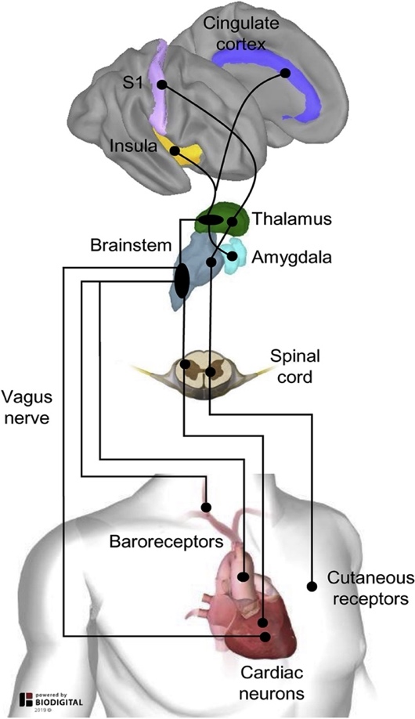
Interoception is responsible for sensing, interpreting, and integrating the body's physiological conditions (e.g., hunger, thirst, pain), thus providing a moment-to-moment map of the body's internal milieu (Berntson & Khalsa, 2021; Craig, 2003). Interoception requires a complex signaling system of the afferent (bottom-up) pathways. A big focus of interoception research has been on cardiac signals as one of the most prominent interoceptive signals. Precise pathways underlying this bottom-up signaling are mostly unknown. Current Research has started to produce several possible physiological heart-brain pathways (Critchley & Harrison, 2013; Park & Blanke, 2019; Tallon-Baudry et al., 1996). The most thought of pathways starting from the heart are (i) the baroreceptors in the aortic artery travelling over the vagus nerve to the brainstem, (ii) the cardiac neurons, in the heart's walls, that signal through the vagus nerve or the spinal cord to the brainstem, and (iii) the cutaneous receptors in the skin detect cardiac changes and transfer them via the spinal cord to the brainstem. From there, they are relayed through the thalamus and terminate at the amygdala (Garfinkel & Critchley, 2016), insula (Strohman et al., 2024), primary somatosensory cortex (Kern et al., 2013) and cingulate cortex (Cambi et al., 2024; for review see Critchley & Harrison, 2013) (Figure 1). A connection between interoception and psychomotor processes have inferred the basal ganglia, specifically the neostriatum in a possible afferent pathway (Critchley & Harrison, 2013).
Figure 1 Possible pathways from the heart to the brain. Cardiac neurons and Barorecptors can signal over the vagus nerve to the brainstem, and baroreceptors and cutaneous receptors can signal over the spinal cord to the brainstem. From there signals are relayed over the Thalamus onto the Amygdala, Insula, primary somatosensory cortex and the cingulate cortex. Figure credit from Park et. al., 2019
Moreover, findings in rodents suggest that cerebral blood pressure changes directly affect local neural activity. One study has seen changes in spontaneous firings after blood pressure alterations in rat slices (Kim et al., 2016). A more recent study in mice found specific baroreceptors in neural populations that open solely to the frequency of the cerebral arteries’ blood pressure (Jammal Salameh et al., 2024). Thus, indicating that there might be more and farther complex mechanisms at work for bottom-up signaling between head and heart.

Measuring the heart-brain interaction
The increased research interest in cardiac signals has expressed itself in new behavioral and physiological measurements to help understand the intricacies of the heart-brain axis as the starting point for interoception. Behaviorally, the heartbeat counting task (Dale & Anderson, 1978; Schandry, 1981), the heartbeat discrimination task (Brener & Ring, 2016; Whitehead et al., 1977), and emotional arousal tasks (e.g. as in Gray et al., 2007; Marshall et al., 2018) have been used. Recently, the heartbeat counting task has faced repeated criticism as it utilises prior knowledge of heart rates which leads to biases and is confounded by other non-interoceptive processes (Desmedt et al., 2018; Murphy et al., 2020). A key physiological measurement for cardiac signals is heart rate variability (HRV). It reflects the variation in the interval between consecutive heartbeats (Inter-beat Interval, IBI), quantified from R-peak to R-peak measurements in an electrocardiogram (ECG) (Laborde et al., 2017). Thus, it shows the dynamic mechanism between the autonomic nervous system (ANS) and cortical interoceptive areas (Garrett et al., 2023). Findings show a positive correlation between interoceptive accuracy and higher HRV, suggesting that our ANS can modulate our interoceptive awareness (Lischke et al., 2021; Owens et al., 2018).
HRV recordings in resting state measurements?
Neurophysiologicly, the main contender for quantifying interoception is the heartbeat evoked potential (HEP). The HEP is based on electrophysiological data (e.g. electroencephalography (EEG), local field potential (LFP), intracranial EEG or MEG), which is time-locked to the R-peaks of simultaneously measured ECG. Thus, reflecting the cortical processing of cardiac activity (Coll et al., 2021; Park & Blanke, 2019; Schandry, 1981) and more recently been connected to interoception on a broader level (Coll et al., 2021). HEP recordings are often investigated by comparing groups (Pollatos & Schandry, 2004) or using behavioral tasks (Marshall et al., 2018; Schulz et al., 2015). Resting-state recordings to investigate HEP were mainly acquired for clinical studies (Müller et al., 2015; Pang et al., 2019; Schulz et al., 2018). But especially rest recordings might be insightful when looking beyond the HEP as an ERP.

Source Dynamics of the HEP
Research into the mechanisms and neural sources underlying HEP has only been picked up in recent years (Park & Blanke, 2019). One intracranial EEG study found using resting-state data that changes in HEP, in the time-frequency domain, show no time-locked changes in power but significant changes in phase coherence around 200ms after the R-peak in 4-10Hz (theta range) (Park et al., 2018). These findings, applying inter-trial coherence (ITC), led the authors to propose the hypothesis that the underlying mechanisms generating the HEP are not based on amplitude changes time-locked to the heartbeat but on a phase-resetting of the oscillations (Sauseng et al., 2007). The heartbeat resets, as the name suggests, he phase of the oscillations creating a significant phase coherence after the R-peak, which, in an event-related potential analysis, is seen as the HEP. Further competing theories have not been presented for the source dynamics of HEPs.
Delta and theta in the source dynamics and their role
Delta increased coherence during interoception social task, delta power inhibited in the prefrontal during meditation vs controls

However, one should be aware that studies investigating HEP face a multitude of challenges. Comparisons between HEP studies are difficult due to low standardization during preprocessing, choices of HEP epochs, baseline windows and differences in the experimental designs (Park & Blanke, 2019). Further, in scalp-based recordings around the R-peak, there is a visual artefact called the Cardiac Field Artifact (CFA) (Dirlich et al., 1997; Park & Blanke, 2019). This occurs due to the strong electrical field generated by the heart itself. Computational measures have been used to remove the CFA, such as independent component analysis (ICA), subtraction method, and principal component analysis (PCA). These approaches have been found to be effective in removing prominent CFA from the HEP. However, they seem to not remove all artefactual components reliably (Park et al., 2014) and might remove important HEP components (Park & Blanke, 2019). The CFA is thought to not disturb the signal around the T-wave (Dirlich et al., 1997; Gray et al., 2007; Park et al., 2014), creating a way to use non-computational interventions. Conversely, the CFA has only a negligible effect on intracranial recordings and can be disregarded for those measurements (Park & Blanke, 2019). Although, a different artifact comes into play with intracranial recordings, the pule pressure artifact (PPA), which is based on the electrical signals of the pulse travelling through the cerebral arteries (Kern et al., 2013; Park et al., 2018). No common practice dealing with the PPA has been established since there are currently only a few studies that have investigated HEP using intra-cranial recordings. One study showed that using time-frequency analysis could be useful for removing PPA, as PPA is characterized by a low and repetitive oscillatory pattern below 2Hz (Park et al., 2018). The specific Hz range of a subject’s PPA can be calculated using their ECG heart rate values. Thus, using a high-pass filter above 2Hz, which is above a healthy humans Hz frequency of the heartbeat, is for now thought to suffice in removing the principal influences of the PPA on the HEP in intracranial recording.
Consideration of harmonics in the TFA thourgh the PPA
However, more research on the PPA and measures to extract it from the data is needed.

Recordings
The main reason for the integration of local field potentials (LFP) from deep brain stimulation (DBS) electrodes in the subthalamic nucleus (STN) and EEG is to understand the dynamics of the HEP in the cortical and subcortical areas. As mentioned above, areas in the subcortex are possibly used for relaying the signal (thalamus) and as a target region (amygdala). Although of high interest, especially recordings in subcortical regions in humans are limited to clinical purposes and clinical targets. Thus, the choice of the STN as a recording site for the subcortical measurements which is not mentioned in the possible pathways. It is clinically a highly important implantation site in Parkinson’s Disease (PD) patients for improved motor function (Bove et al., 2021; Lachenmayer et al., 2021). Taking into consideration, the new findings of a possible mechanism based on blood pressure through specific baroreceptors in neurons (Jammal Salameh et al., 2024). Based on this finding and the fact that precise pathways for the HEP are currently unknown, it can be argued that all areas in the brain, not only the ones in the possible pathways, receive cardiovascular signals. Furthermore, possible neostriatal projections in the heart-brain pathways implicate the basal ganglia in their dynamics (Critchley & Harrison, 2013). The STN being part of the basal ganglia could suggest that cardiac activity could be recorded from the STN-DBS electrodes. The experimental analysis of the subcortical data of the STN could shed some light on the dynamic influence of cardiac signals on areas outside of the possible pathways. Furthermore, the simultaneous recordings of cortical and subcortical electrodes offer the unique possibility of investigating the integration of cortical and subcortical HEP mechanisms underlying the HEP.

Aim of the project
Following the reported literature, this thesis aims to further advance the understanding of the neural source dynamics of HEPs. The simultaneous cortical EEG and intracranial subcortical LFP recordings offer a novel opportunity for the research into HEPs. HEPs are recorded during the eyes-open resting state in both Medication Off (MedOff) and Medication On (MedOn) conditions to assess naturalistic neural processing of the heartbeat, sans the behavioral tasks and influences. Medication Off refers to the state of PD patients who have not taken their dopaminergic medication for at least six hours (SOURCES). Based on the literature, we do not expect to see HRV-related changes regarding medication but to see the HEP in both cortical and subcortical data. Furthermore, replicating the findings from Park et. al (2018), we envision that after time-frequency analysis, there are no changes in power in the data, but we can see significant phase coherence using ITC around the HEP timings in both cortical and subcortical recordings. Following that, we hypothesis that phase coherence between cortical and subcortical electrodes using cross-channel coherence (CCC), especially ipsilaterally, is significant in line with the HEP timings.

Methods

Patients and surgery
Fourteen PD patients (7 female) who underwent bilateral STN-DBS surgery participated in this study. At the time of the recording, their mean age was 60 years (± 1.5 years SEM), with an average disease duration of 11 years (± 1.6 years SEM). Participants were recruited from King’s College Hospital NHS Foundation Trust and St. George’s University Hospital NHS Foundation Trust, both located in London, United Kingdom. All patients gave their written and informed consent to participate in this study. The local ethics committee approved this study (St. George's University Hospital, IRAS: 46576; King’s College University Hospital, IRAS: ###). The patient’s clinical details (and location of the DBS electrodes) can be found in Table 1
For the leads the clinicians used the Medtronic 3389 (Medtronic Inc., Neurological Division, USA) with four 0.5 mm spaced contacts of 1.5 mm length with platinum‐iridium cylindrical surfaces, or the directional leads from Boston Scientific (model DB-2202, Boston Scientific, USA) or St. Jude Medical (model 6170, St. Jude Medical, now Abbott, USA), both having three segmented contacts on the middle levels. DBS implantation was guided by magnetic resonance imaging. (St. George's University Hospital).

Sub. | Gender (f/m) | Age (yr) | Disease duration (yr) | Pre-OP UPDSR-III  OFF | Pre-OP UPDSR-III  ON | Pre-dominant symptoms
1 | m | 57 | 11 | 41 | 16 | Rigidity
2 | m | 59 | 6 | 31 | 4 | Tremor, anxiety with panic attacks
3 | f | 63 | 10 | 29 | 6 | Bradykinesia
4 | m | 63 | 20 | 51 | 27 | Tremor
5 | f | 62 | 7 | 39 | 5 | Tremor
6 | f | 63 | 10 | 29 | 8 | n/a
7 | f | 64 | 14 | 31 | 17 | Tremor
8 | f | 65 | 7 | 23 | 4 | Tremor
9 | f | 55 | XXX | 42 | 16 | n/a
10 | f | 67 | 20 | 55 | 32 | n/a
11 | M | 50 | 7 | n/a | n/a | Rigidity, bradykinesia
Table 1 Patients’ clinical data.

Data Recording
All patients were recorded once with Levodopa medication taken and confirmed to be in effect. For 8 subject another recording could be done with an overnight withdrawal from Levodopda medication. The LFP recordings were done on externalised DBS electrodes around 2 to 5 days after surgery and before the implantation of the subcutaneous pulse generator. For the EEG recordings, seven electrodes were placed in frontal, central, and parietal locations (F3, F4, C3, C4, Cz, P3, P4, Pz). ECG was recorded using two bipolar electrodes placed horizontally and vertically along the left torso. All electrodes used a reference electrode located on the inner wrist of the patients. All signals were measured and amplified (at 2048Hz) with a TMSi Porti and its respective software (TMS International, Netherlands) on a recording laptop.

Study Design
During the recording, the participants were seated comfortably in an armchair. For this thesis, the required data was resting data. The patients were asked to sit relaxed with eyes open for about 5 minutes. These 5-minute recordings were done with the medication present (MedOn) and, when possible, after the medication withdrawal (MedOff).

Signal preprocessing
All signal processing was done using MATLAB (v. 2024a, Mathworks, Massachusetts; USA) with custom-written scripts. All written code has been made available on the author’s GitHub (https://github.com/lipaulsen/HeadHeart). Spike2 (v. 7.2, Cambridge Electronic Design Limited) was used for the initial visual inspection. R-peak detection in the ECG Signal was done within Spike2 and manually checked. Visual cleaning was done via the exclusion of R-peak trials when major artefacts were present in the EEG and LFP data.

Electrocardiogram (ECG)
The ECG data was cleaned by removing the DC Offset, and a two-pass 2nd order Butterworth band-pass filter (0.5Hz high pass; 30Hz low pass). The filters used were from the fieldtrip toolbox (Oostenveld et al., 2011). Afterwards, the Inter-beat Interval (IBI) and the heart rate (HR) of each patient were calculated. Using the IBI the HRV was extracted (Figure 2 B). These cardiac data features (R-peak, IBI, HR, HRV) were chosen, in this exploratory analysis, as they represent a broad field of information from the ECG signal with a solid theoretical background and complement the goals of this thesis.
B
A
Figure 2 Preprocessing Pipeline. (A) The preprocessing for the EEG and LFP starts with visual artifact detection and removal in Spike2. Switching to MATLAB filtering with 50Hz Notch, High-pass at 0.1Hz and low-pass at 100Hz was done. An additional high-pass filter at 0.5Hz for EEG and 2Hz for LFP was done to take care of the PPA artifact in the LFP data. The LFP data was bipolar re-referenced and all data was down sampled to 300 and epoched time-locked to the R-peak and in the area of interest around -300ms to 600ms. All signals were baseline corrected from each epoch the values from -300ms to -100ms are subtracted. Ultimately the data was transformed into the time-frequency domain using the IIRPeak and Hilbert transform. (B) ECG data was visually inspected for artifact rejection and R-peak detection was automatically done in Spike two through amplitude thresholding. All detected R-peaks were manually checked. In MATLAB the DC Offset was calculated and the data was bandpass filtered at 0.5 to 30Hz. This lead to the calculation of the IBI and the HR through the ECG signal.

Electroencephalography (EEG) and local field potential (LFP)
The EEG and LFP data were visually inspected using Spike2, and periods with a lot of visual noise were removed. In MATLAB the data was high- and low-pass filtered using a two-pass 4th order Butterworth high-pass filter at 0.5Hz and the same configuration for the low-pass filter at 100Hz (Figure 2 A).
As mentioned in the introduction, the PPA needs to be accounted for in LFP measurement. The mean heart rate over all subjects was 1.28Hz (± 0.16Hz, min 1.06Hz, max 1.65Hz). Based on this, and the fact that pulse-related oscillatory artifacts occur below 2Hz, an additional 2Hz high-pass filter was applied. Another intracranial study used a high-pass filter at 4Hz for a more conservative approach (Park et al., 2018). After consideration, the more liberal 2Hz cutoff was chosen for this data to retain the most signal information while still removing the PPA. The additional high-pass filter was not applied for the EEG data since the PPA is not present in that data. Considering the several methods for removing the CFA, both computational (ICA, PCA, subtraction) and non-computational (HEP time-window selection), the non-computational method was chosen. The CFA decreases to less than 1% during the period of the t-wave until the next R-Peak compared to ECG amplitudes at the chest (Dirlich et al., 1997; Park & Blanke, 2019). Thus, the restricted time window between shortly before the T-Wave to the next R-Peak was chosen as the area of interest. So, this area of interest can be used to measure HEP without CFA contamination and potential signal loss through computational methods.

Second, we also wanted to remove higher order harmonics of PA (e.g., second and third order) that could be potentially observed in 2–4Hz frequency band (Norcia et al. 2015). Third, we hypothesized that phase modulation would be associated with ongoing theta (4–7Hz), alpha (8–12 Hz), and low-beta (13–20 Hz) oscillations, based on previous studies investigated ITC modulation in sensory evoked potentials such as visual evoked potentials (Makeig et al. 2002) and auditory evoked potentials (Fuentemilla et al. 2006).

The EEG data and LFP data used the common average reference for re-referencing. Additionally, the LFP data was re-referenced using the bipolar re-referencing method, which is commonly used in LFP data from DBS electrodes (Li et al., 2018). Effectively this leads to one electrical signal representing for the STN per hemisphere. The filtered and re-referenced data was resampled to 300 Hz, to speed up the computation. The data was epoched around 300ms before till 600ms after the R-peak. Baseline correction was performed using 200ms of data from the 300ms to 100ms before the R-peak of each epoch. Time-frequency decomposition was performed using first an IIR Peak Filter with a Bandwidth of 2Hz and the attenuation QFac of 2Db with 148 frequency bins between 0.5 and 30Hz and a resolution of 0.2Hz. This frequency range was chosen based on previous studies and frequencies of interest of including beta frequency (13-30Hz) since working with PD data (Kern et al., 2013; Park et al., 2018). Afterwards, a Hilbert transform was applied to the filtered data using a function from the fieldtrip toolbox. The EEG spectral power and phase time series at each frequency were extracted by computing the magnitude and angle of the Hilbert-transformed signal across time, yielding time-frequency representations of power and phase dynamics.

Analysis and Statistics
All analysis and statistical code can also be found on the author’s GitHub. The significance level for all statistical analyses was set to α = .05, if not specified otherwise.

ECG Features Analysis
ECG data can distinguish multiple features. Features extracted here are the Heartrate (HR), in the form of beats, as R-peaks, per minute , the Inter-beat Interval (IBI), the duration of time between R-Peak and R-Peak, and the HRV. HRV can be calculated in multiple ways through the ECG signal. The two main approaches discern themselves between frequency-domain or time-domain calculations. Especially in recent studies solely investigating the HRV using the frequency-domain has seen wide appeal due to the ability to differentiate between low-frequency and high-frequency HRV (Fourcade et al., 2024; Malik, 1996). HRV not being the main point of analysis, the Root Mean Sum of Squared Distance (RMSSD) was chosen. It is a widespread and validated approach to HRV calculation that does not use the Fourier transform. The IBI times are squared, averaged over all values, and ultimately the square root is taken over the results.
$$\text{RMSSD}=\sqrt{\frac{1}{N-1}\sum_{i=1}^{N-1}{{\left(RR_{i+1}-RR_{i}\right)}^{2}}}$$
RMSSD values are in ms and reportedly change over the lifetime so a healthy person age 30-40 years has an RMSSD HRV of 30-50ms, whereas this decreases to roughly 20-30ms in the fifties (Tegegne et al., 2020). Clinical diseases can influence the HRV of the clinical population. Taken into account in the analysis is that PD patients RMSSD HRV values are decreased compared to age-matched healthy controls (Heimrich et al., 2021).
All ECG features are compared between MedOn and MedOff condition. To inspect the difference in the features between medication a paired ttest is used. The IBI, HR and HRV values for each subject were averaged and compared between conditions. One limitation is the low number of subjects. For only 8 of the 14 patients both medication conditions datasets are available. Patients opt out of the medication withdrawal, since the increase of PD symptoms during the withdrawal period can be too uncomfortable. One of the eight patients was excluded due to Arrythmia. The patients ECG signal was extremely irregular over the entire recording, which lead to its entire exclusion. Thus, the N for the analysis here is decreased to 7.

HEP Analysis
HEPs were computed on the EEG and LFP signals time-locked to the R-peak. R-peak detection was done using Spike2 via automatically tagging each peak exceeding the global average amplitude on a subject-by-subject basis. All automatically tagged instances were visually inspected and corrected. Epochs (−300 to 600 ms regarding the R-peak onset) presenting excessive artifacts were excluded from the analysis. After artifact rejection, each subject had 451 ± 141 epochs for each electrode. Firstly, epochs for each electrode were averaged to calculate the patients traditional HEP. Subsequently, to the traditional averaging, a hierarchical clustering approach was taken to extract waveforms. Plotting the subjects averages of the HEP it was quite apparent that the average waveforms of the HEP also show high divergence based on polarity. Hierarchical clustering can alleviate this, as it does not average but uses the pure subject-wise waveforms to create clusters over all subjects and channels. The average waveform from each channel of each subject is used. A subject and channel-wise waveforms matrix is shaped within a condition over the epoch. Hierarchical Clustering is performed using Euclidean distance and the ward algorithm. This creates a hierarchical clustering tree that takes XXX into account. MATLAB’s built-in functions were used to compute the hierarchical clustering. A table mapping the subject, channels and clusters is utilised to recover data point assignments. Averaging showed that the shifted polarity of signals lead to averaging out of useful signals. After inspection, clusters with inverse polarity were able to be flipped to correct for averaging out in this case. Hierarchical Clustering was separated into three categories (EEG, STN, ALL) based on which channels are clustered, and the two conditions (MedOn and MedOff).
Statistical analysis compares the HEP group waveforms by either medication (MedOn vs. MedOff) or by location (EEG vs STN). Significance is determined using a paired t-test with FDR correction for multiple comparisons. Testing is done on the entire time epoch time window and on a time window of 100ms to 600ms after R-Peak. The second time window is determined through visual inspection of all configurations, extracting the time range corresponding to the global maxima. Due to the low patient count in STN LFP studies a common practice is to use the STN hemispheres as separate patients (XXX). As this study remains exploratory and has a low number of patients the regular N and the hemispheric split is employed, to discover changes in statistical power.

Include here the change to Hierarchical Clustering due to the Results using Averaging

ITC Analysis
To calculate the phase coherence across single trials within one electrode, ITC was used (Tallon-Baudry et al., 1996). It describes the average of normalised instantaneous phases over single trials (Park et al., 2018)
$$ITC\left(f_{0},t\right)=\frac{1}{N}\left|\sum_{k=1}^{N}{e^{iφ_{k}\left(f_{0},t\right)}}\right|$$
This equation shows the implemented ITC algorithm, where $f_{0}$ is the frequency and $t$ is the time. $N$ is the number of trials and $e^{iφ_{k}\left(f_{0},t\right)}$ converts the phase ($φ_{k}\left(f_{0},t\right)$) into a complex number on the unit circle using Euler’s formula. The resulting values for each trial can range between 0 and 1. A higher value means more coherence during the phase. ITC was calculated for both the EEG and the LFP electrodes for all subjects with the above-described epochs.
The statistical analysis was done in reference to the permutation approach from Park et al. (2018) for their ITC analysis. It uses non-parametric permutation statistics with a surrogate and false discovery rate (FDR) for correction purposes (Benjamini & Hochberg, 1995; Maris & Oostenveld, 2007). Surrogate R-peaks for each channel were created by randomly shifting the original R-peak timings 500ms around the event (-500ms to 500ms around the original R-peak). Thus, shifting period was chosen to keep the integrity of the original IBI and its variability and to keep within one heartbeat. Using the surrogate R-peaks, the channel data were epoched with these new times and transformed to the time-frequency domain. On the surrogate epochs, the ITC was computed as for the original data. This permutation repeated 1000 times, which led to a distribution of ITC values for each electrode that was based on chance observation. The z-scores of the distribution were calculated, and p-values for each electrode were extracted. FDR was applied to the p-values to correct for multiple comparisons. To replicate the finding of the phase-locking theory, a correlation was calculated between the ITC values and the spectral power during the same epochs. Compared to the data presented by Wang (2018), the current data set has fewer data points in total and per subject (474 derivations over 8 subjects in the original data and 108 derivations over 14 subjects). The current data was split into the different recording sites EEG (82 derivations over 14 subjects) and LFP (26 derivations over 14 subjects). The statistical approach was changed to accommodate the fewer derivations. Wang et. al. used a Pearson correlation and z-scored the data within-subject. Due to the fewer data points per subject, z-scoring the data would make the correlation unstable due to heteroscedasticity ( sources). The non-parametric Spearman correlation was used to make the correlation more robust.

PSI/CCC Analysis
Investigating the phase coherence between two electrodes over the trials is done using the Phase Synchronization Index (PSI). In this thesis, it is also referred to as cross-channel coherence (CCC). It calculates the average of the normalised difference of phases over single trials between 2 channels.
$$Ψ\left(f,t\right)=\frac{1}{N}\left|\sum_{k=1}^{N}{e^{i\left(φ_{k}^{\left(1\right)}\left(f,t\right)-φ_{k}^{\left(2\right)}\left(f,t\right)\right)}}\right|$$
$Ψ\left(f,t\right)$ is the PSI values for frequency $f$ and time $t$. N is the number of trials with $φ_{k}^{\left(1\right)}\left(f,t\right)$ representing the phase angle of signal 1 of trial $k$ at the certain frequency and time. This is subtracted by the phase angle of signal 2. Where than using the Euler’s formula the complex phase difference is calculated out of. As with the ITC the PSI values range between 0 and 1 with a higher values indicating higher coherence.
Following the permutation approach from ITC the CCC analysis also uses surrogate R-peaks to create a range of surrogate epochs. Now two channels are used for this analysis at the same time and the CCC is calculated as for the original CCC data. The permutation runs 500 times and following that Z-scores and p-values are extracted from the permutation distribution. These are then controlled for multiple comparison using FDR.
Explain why Perm didn’t work
Perm distribution was skewed maybe show plot of skewedness
General ITC distribution is very normal
Understand tahat maybe a parametric test is the best option to further tstaistical analysis (also check for the other stats paraemtic voraussetzungen)
What stats after?

Results

ECG features show no modulation by medication
ECG data features that are analysed here are IBI, HR, and HRV. We can distinguish between ECG data for MedOn and MedOff patients based on the patient data. As this thesis is an explorative analysis, a potential distinction between MedOn and MedOff in ECG features might lead to a different view on the following analysis. The median IBI is a bit lower in MedOn (800ms) than MedOff (900ms). The statistical analysis does not show a significant difference between medications.
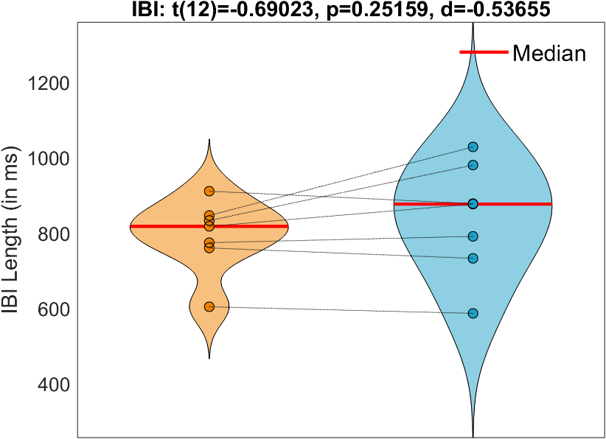
Figure 3 Statsistical Analysis of the IBI between MedOn and MedOff. This violin plot shows the distribution, median (red line) and the individual data points of the IBI in both MedOn and MedOff data. Data points from same subjects are connected via a thin black line. IBI Length is depicted on the y-axis in ms.

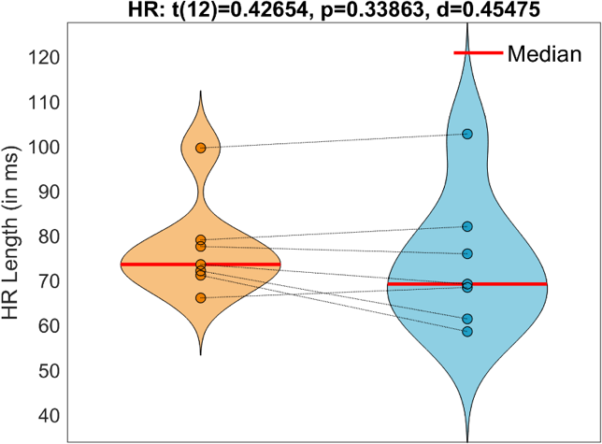
Looking that the HR the median HR of all patients with MedOn is XX ms and MedOff XX ms. The paired t-test reveals no significant difference in HR by medication (Fig.).
Figure 4 Statsistical Analysis of the Heartrate between MedOn and MedOff. This violin plot shows the distribution, median (red line) and the individual data points of the HR in both MedOn and MedOff dtaat. Data points from same subjects are connected via a thin black line between conditions. Length of the HR is depicted in ms on the y-axis. A paired t-test revealed no significant difference in HR.

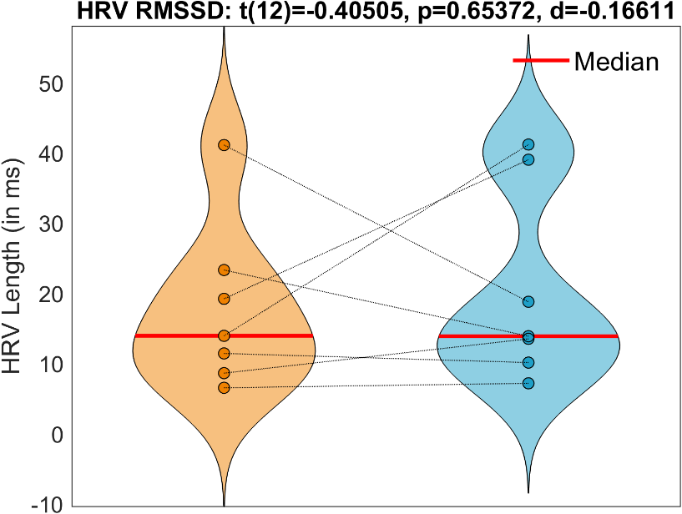
Switching to the HRV Analysis the median as well as the statsictical analysis of the HRV does not show significant differencemodulated by mediation. Some single subjects HRV does differ a lot between MedOn and MedOff but this does not influence the group analysis.
Figure 5 Statsistical Analysis of the HRV between MedOn and MedOff. This violin plot shows the distribution, median (red line) and the individual data points of the HRV in both MedOn and MedOff data. Data points from same subjects are connected via a thin black line. HRV Length is depicted on the y-axis in ms.

HEP Results

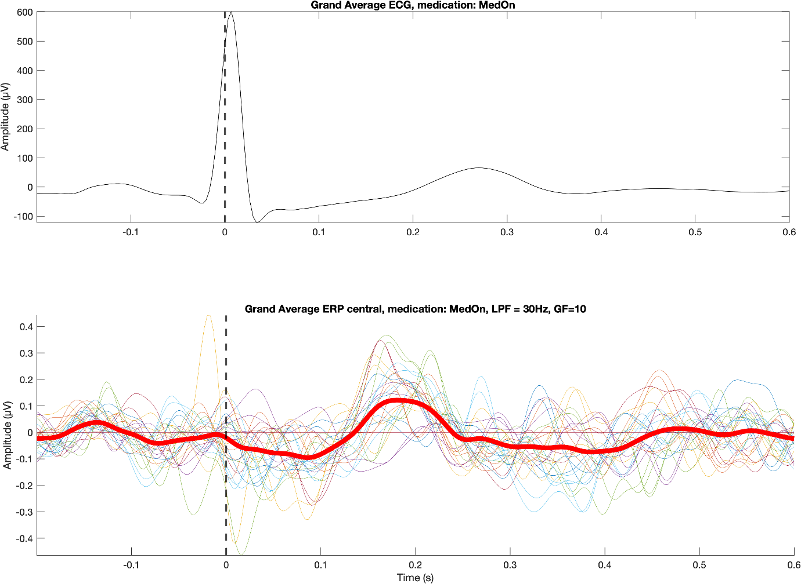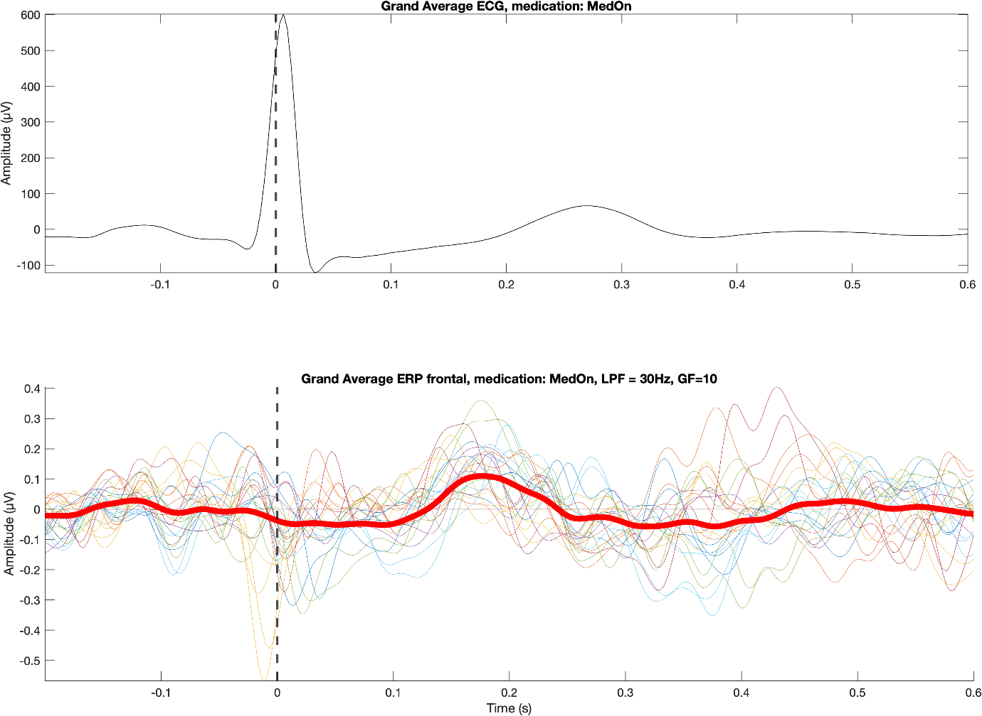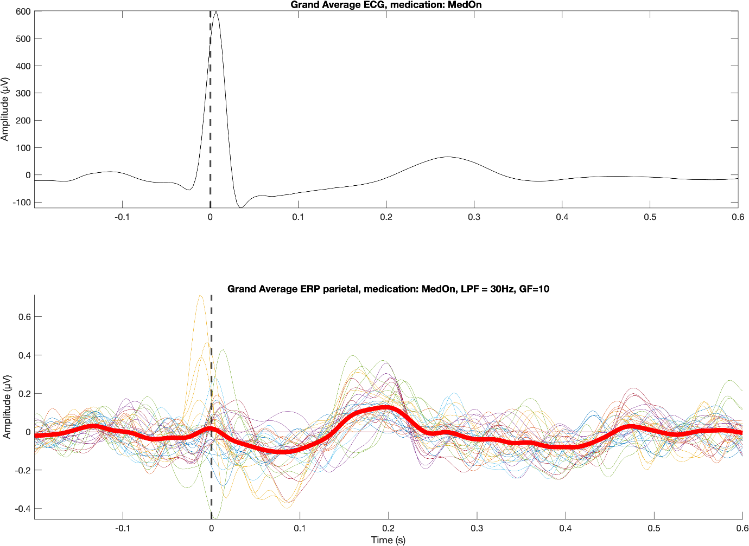
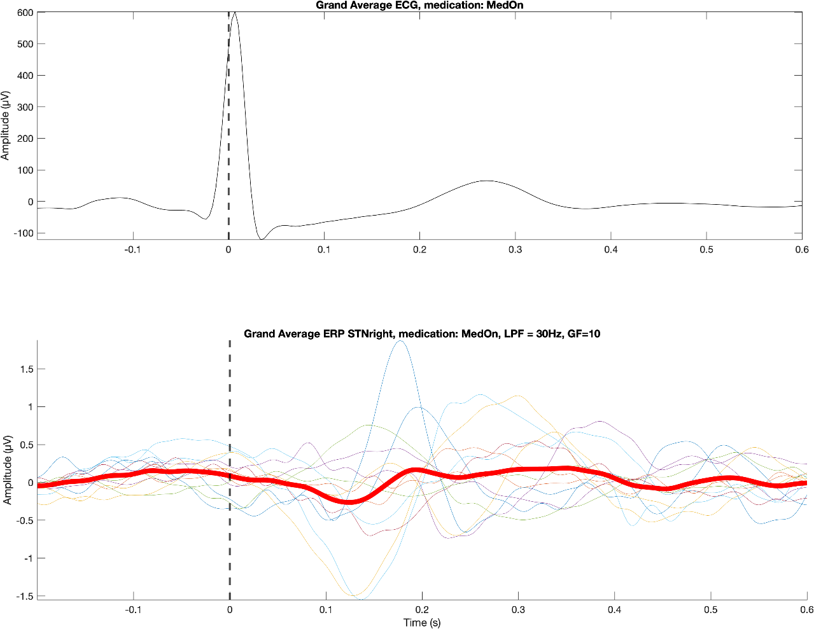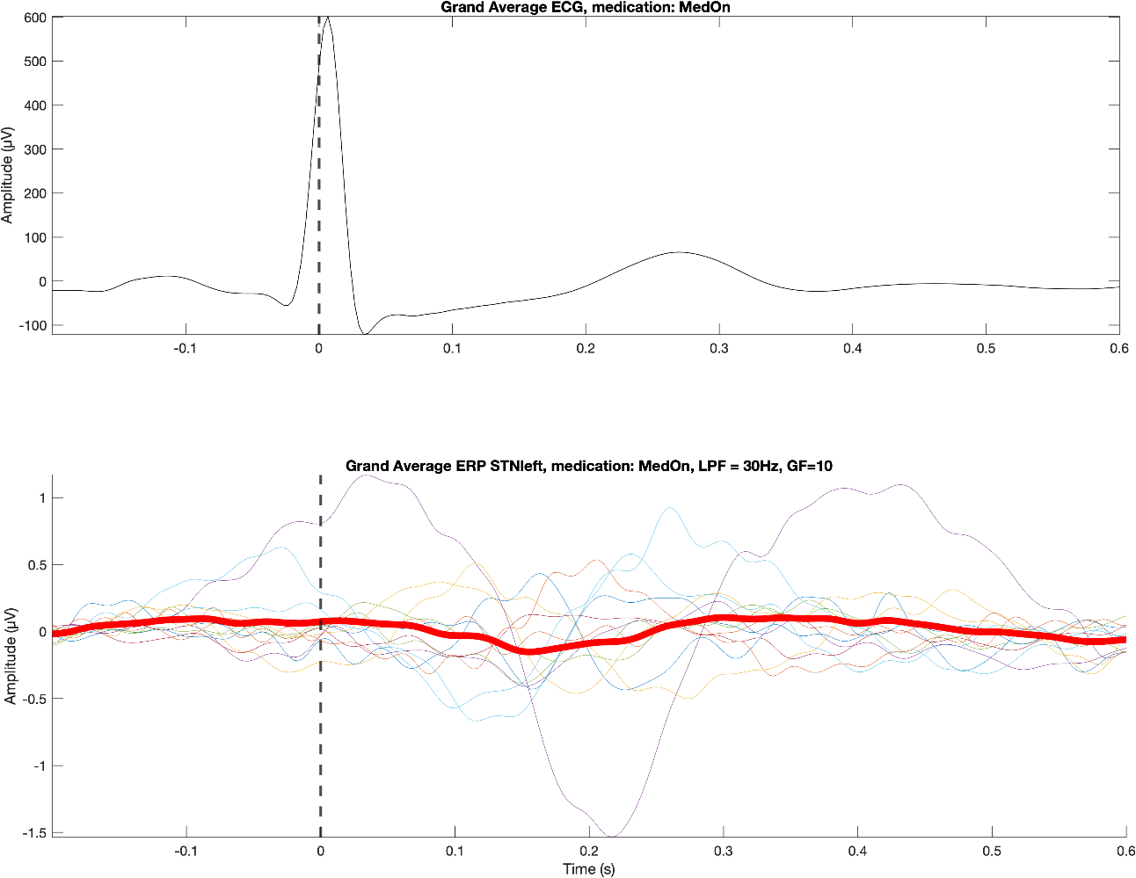

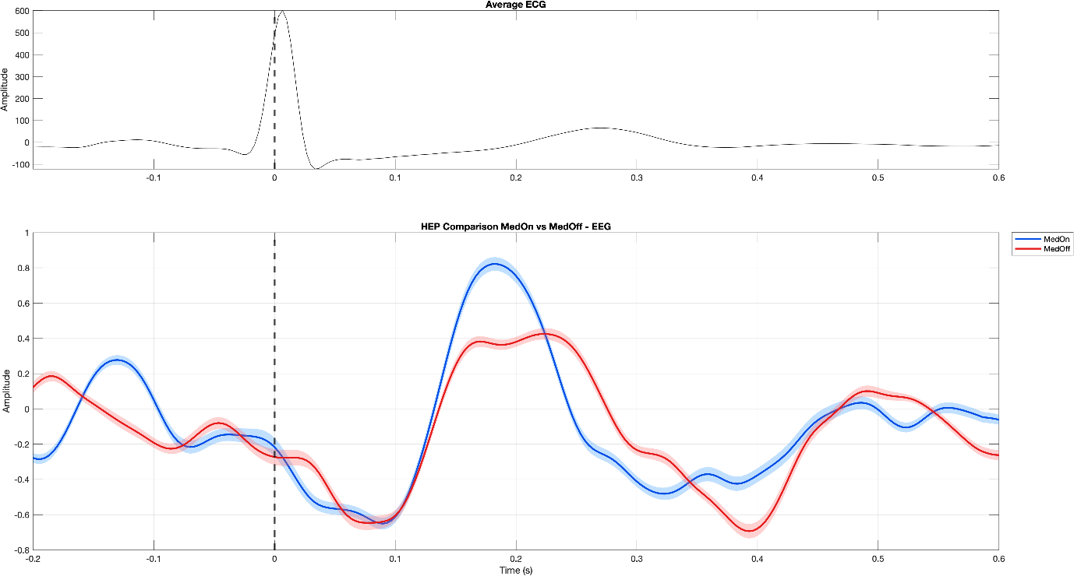

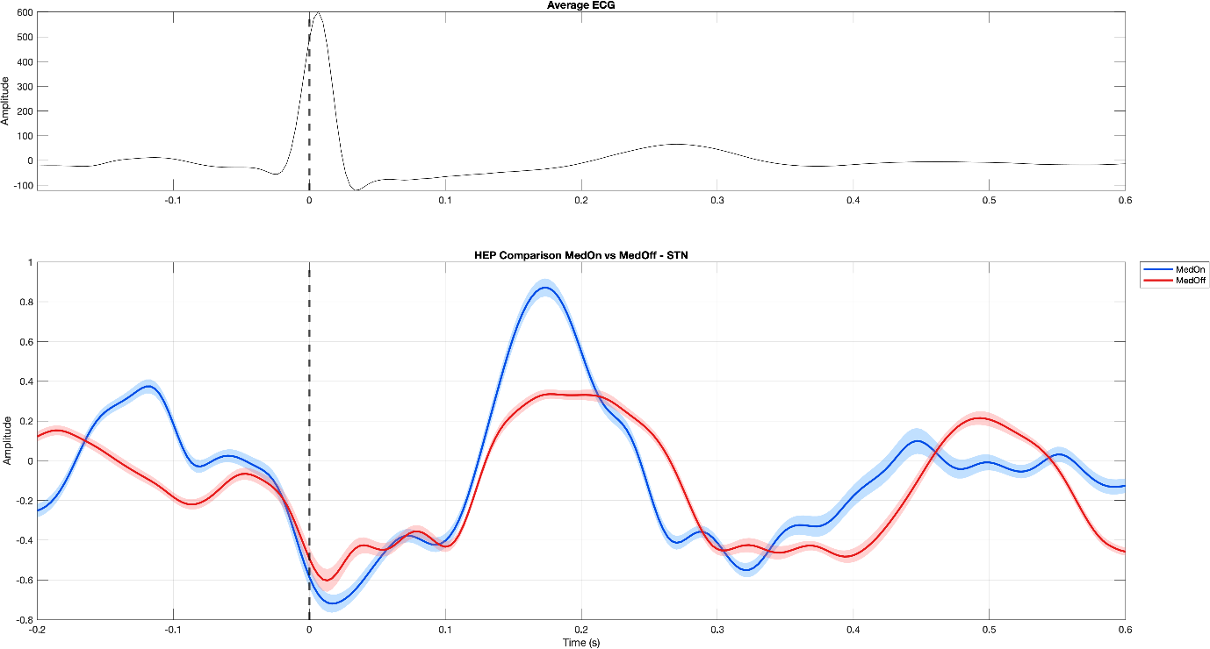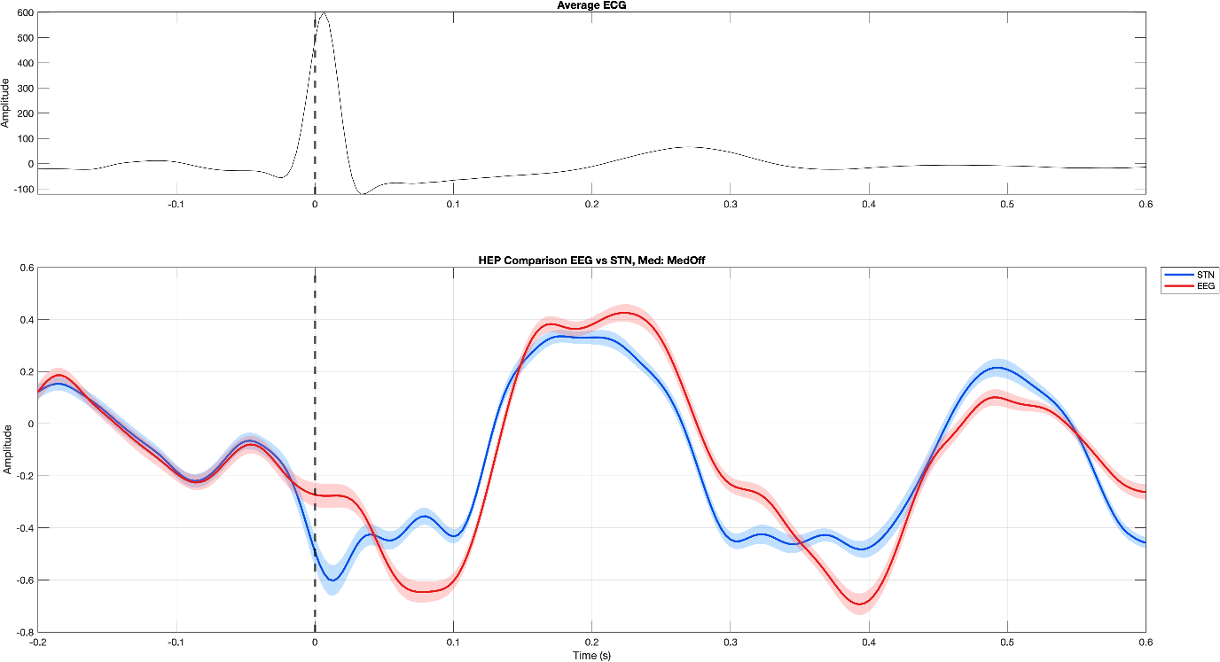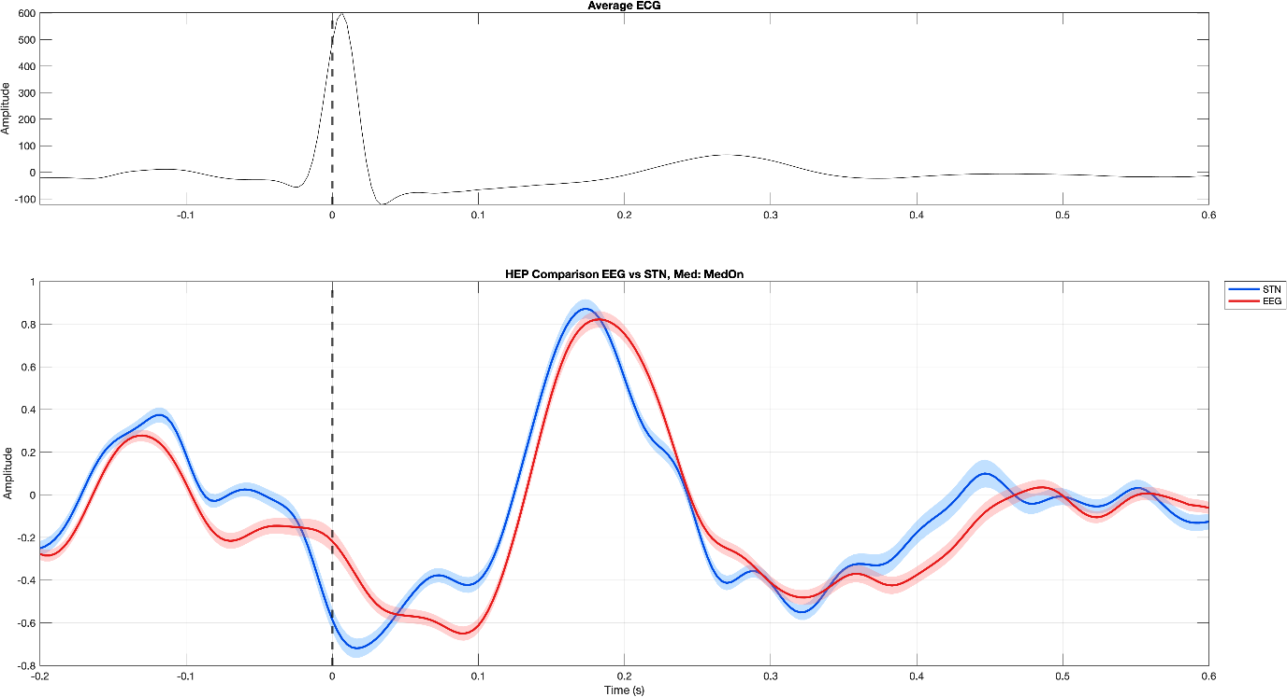

ITC Results

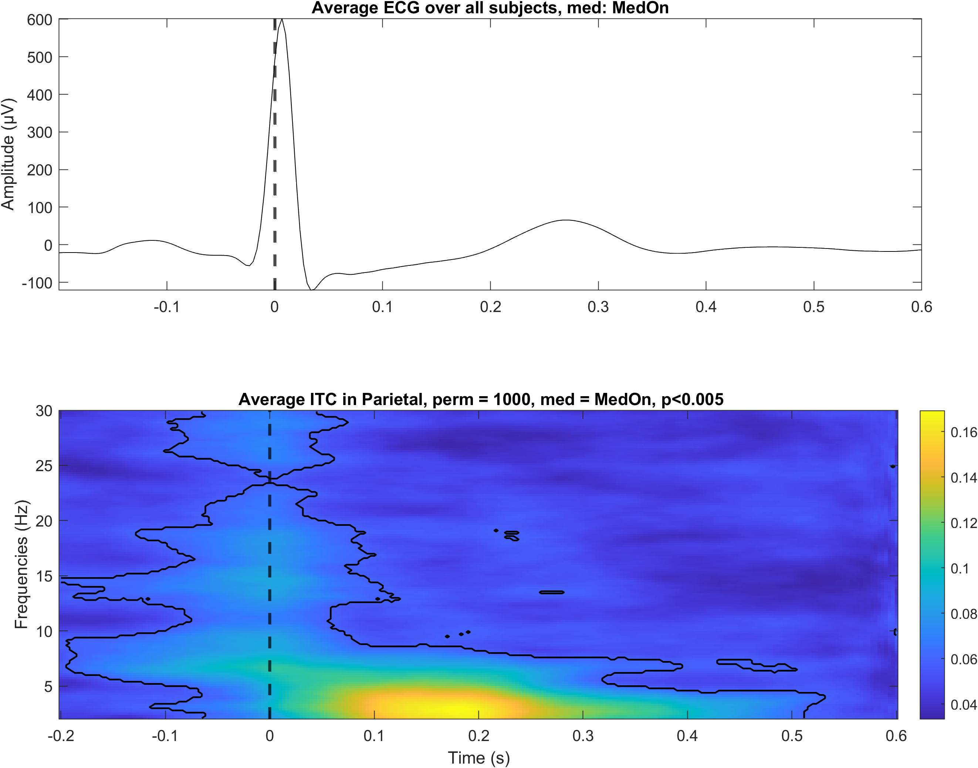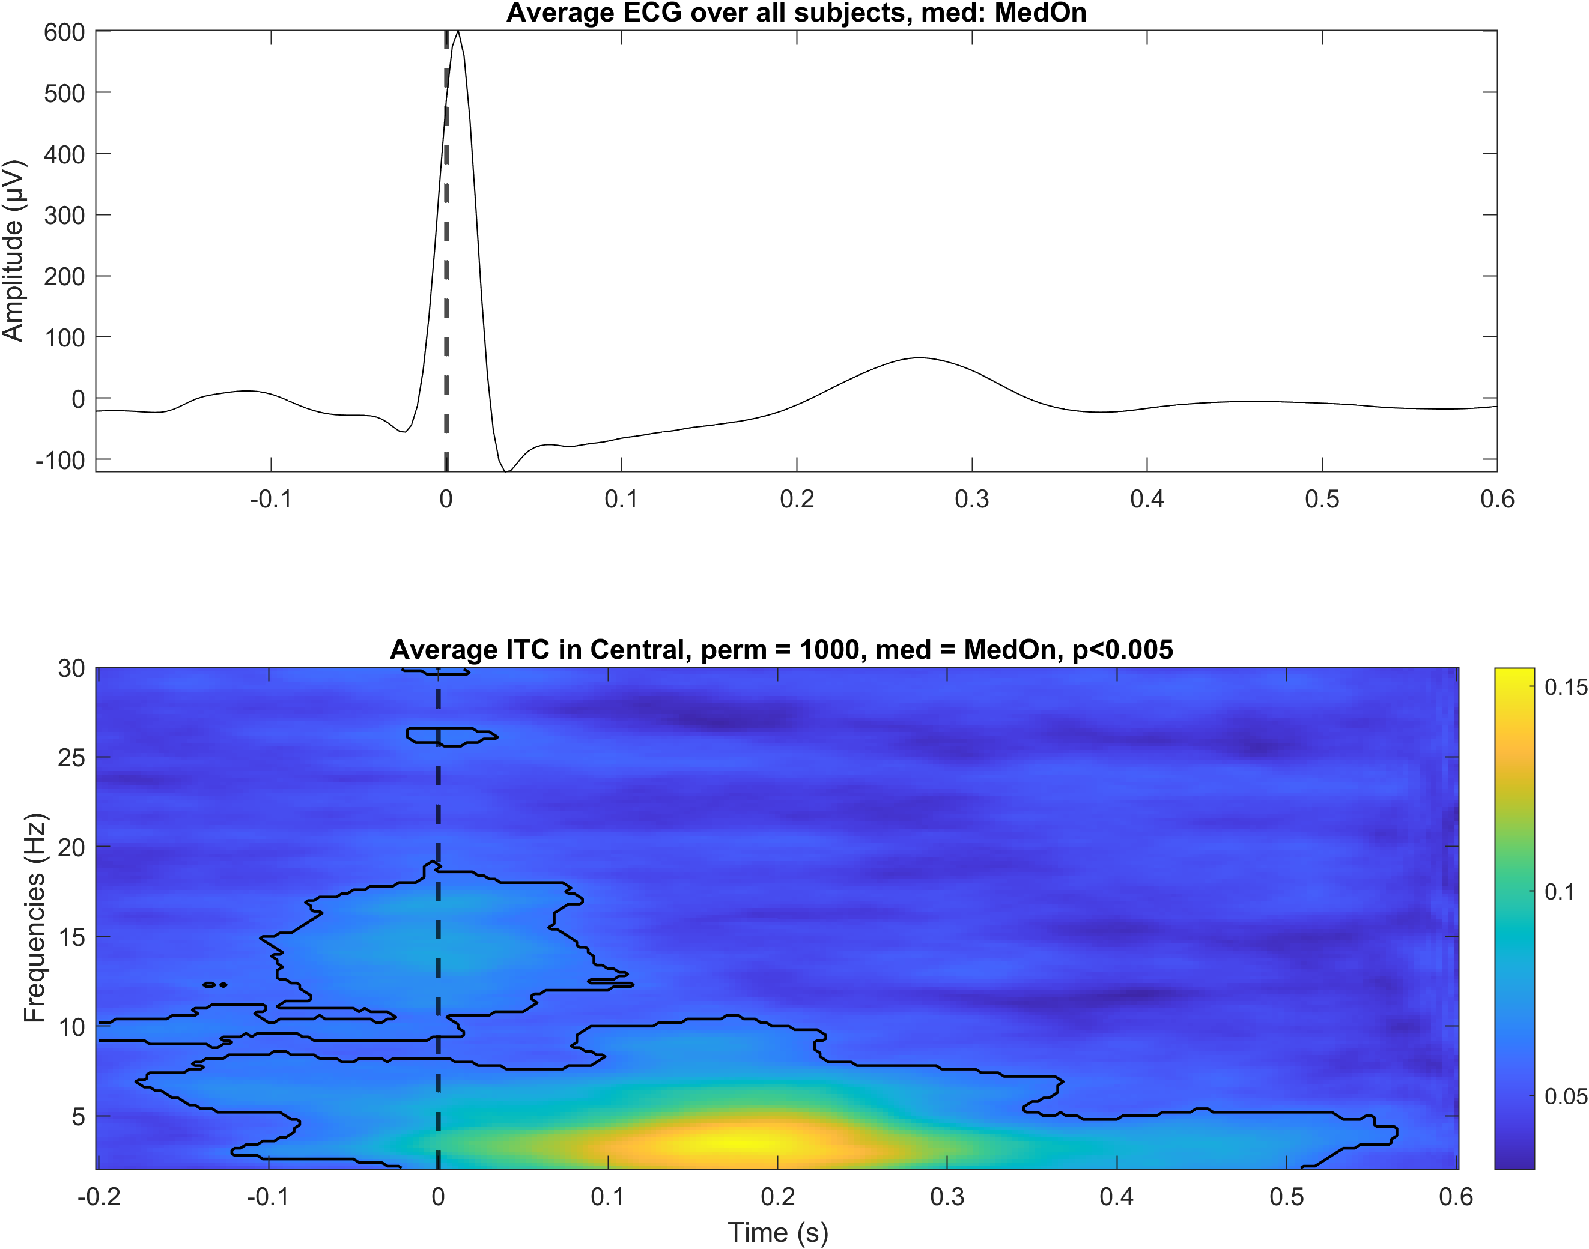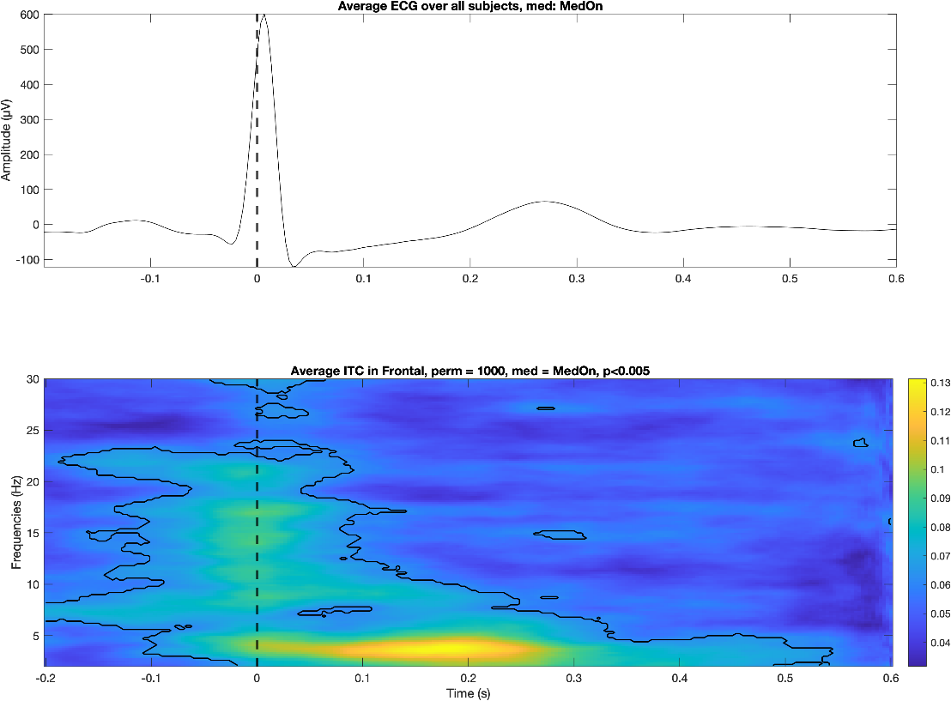
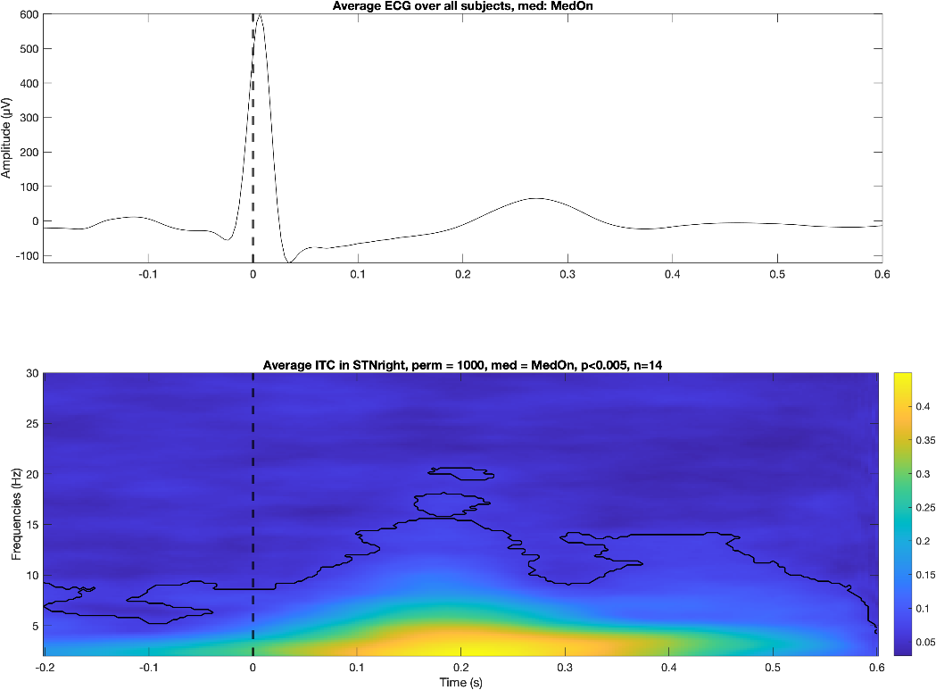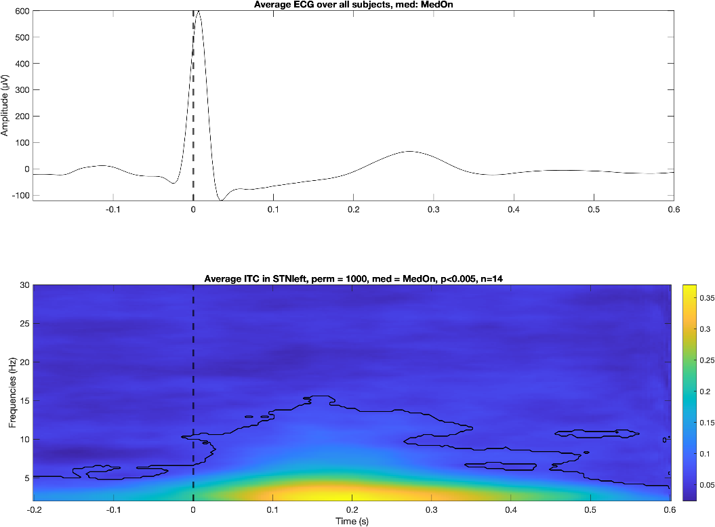

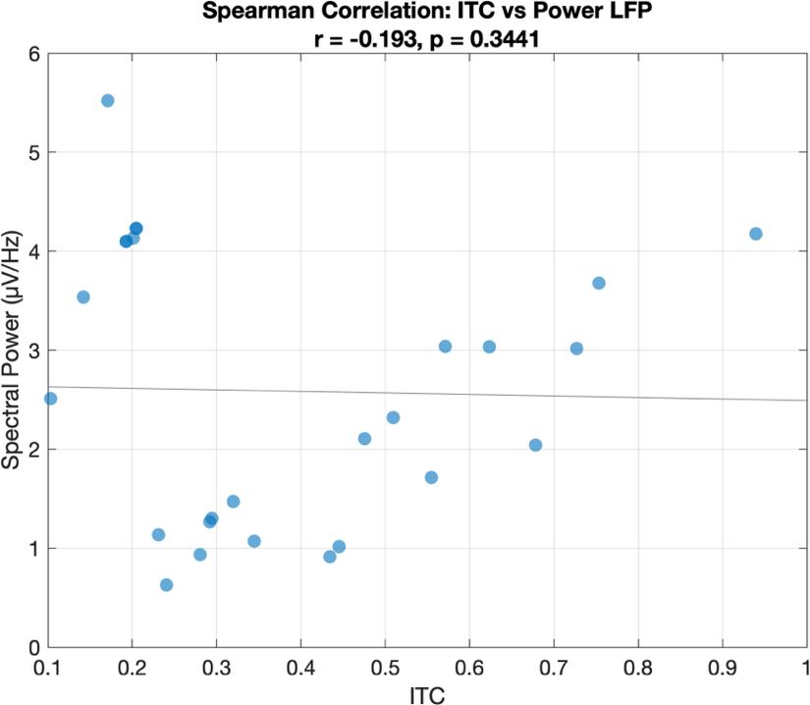
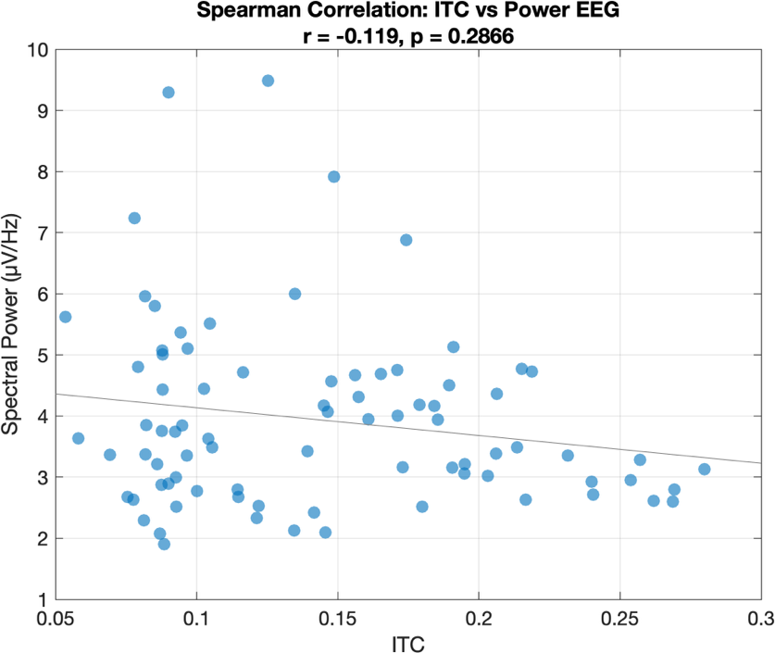

PSI/CCC Results

Discussion

References
Benjamini, Y., & Hochberg, Y. (1995). Controlling the False Discovery Rate: A Practical and Powerful Approach to Multiple Testing. Journal of the Royal Statistical Society, 57(1), 289–300. https://doi.org/10.1111/j.2517-6161.1995.tb02031.x
Bove, F., Mulas, D., Cavallieri, F., Castrioto, A., Chabardès, S., Meoni, S., Schmitt, E., Bichon, A., Di Stasio, E., Kistner, A., Pélissier, P., Chevrier, E., Seigneuret, E., Krack, P., Fraix, V., & Moro, E. (2021). Long-term Outcomes (15 Years) After Subthalamic Nucleus Deep Brain Stimulation in Patients With Parkinson Disease. Neurology, 97(3). https://doi.org/10.1212/WNL.0000000000012246
Brener, J., & Ring, C. (2016). Towards a psychophysics of interoceptive processes: The measurement of heartbeat detection. Philosophical Transactions of the Royal Society B: Biological Sciences, 371(1708), 20160015. https://doi.org/10.1098/rstb.2016.0015
Cambi, S., Solcà, M., Micali, N., & Berchio, C. (2024). Cardiac interoception in Anorexia Nervosa: A resting‐state heartbeat‐evoked potential study. European Eating Disorders Review, 32(3), 417–430. https://doi.org/10.1002/erv.3049
Coll, M.-P., Hobson, H., Bird, G., & Murphy, J. (2021). Systematic review and meta-analysis of the relationship between the heartbeat-evoked potential and interoception. Neuroscience & Biobehavioral Reviews, 122, 190–200. https://doi.org/10.1016/j.neubiorev.2020.12.012
Critchley, H. D., & Harrison, N. A. (2013). Visceral Influences on Brain and Behavior. Neuron, 77(4), 624–638. https://doi.org/10.1016/j.neuron.2013.02.008
Dale, A., & Anderson, D. (1978). Information Variables in Voluntary Control and Classical Conditioning of Heart Rate: Field Dependence and Heart-Rate Perception. Perceptual and Motor Skills, 47(1), 79–85. https://doi.org/10.2466/pms.1978.47.1.79
Desmedt, O., Luminet, O., & Corneille, O. (2018). The heartbeat counting task largely involves non-interoceptive processes: Evidence from both the original and an adapted counting task. Biological Psychology, 138, 185–188. https://doi.org/10.1016/j.biopsycho.2018.09.004
Dirlich, G., Vogl, L., Plaschke, M., & Strian, F. (1997). Cardiac field effects on the EEG. Electroencephalography and Clinical Neurophysiology, 102(4), 307–315. https://doi.org/10.1016/S0013-4694(96)96506-2
Fourcade, A., Klotzsche, F., Hofmann, S. M., Mariola, A., Nikulin, V. V., Villringer, A., & Gaebler, M. (2024). Linking brain–heart interactions to emotional arousal in immersive virtual reality. Psychophysiology, 61(12), e14696. https://doi.org/10.1111/psyp.14696
Garfinkel, S. N., & Critchley, H. D. (2016). Threat and the Body: How the Heart Supports Fear Processing. Trends in Cognitive Sciences, 20(1), 34–46. https://doi.org/10.1016/j.tics.2015.10.005
Garrett, L., Trümbach, D., Spielmann, N., Wurst, W., Fuchs, H., Gailus-Durner, V., Hrabě De Angelis, M., & Hölter, S. M. (2023). A rationale for considering heart/brain axis control in neuropsychiatric disease. Mammalian Genome, 34(2), 331–350. https://doi.org/10.1007/s00335-022-09974-9
Gray, M. A., Taggart, P., Sutton, P. M., Groves, D., Holdright, D. R., Bradbury, D., Brull, D., & Critchley, H. D. (2007). A cortical potential reflecting cardiac function. Proceedings of the National Academy of Sciences, 104(16), 6818–6823. https://doi.org/10.1073/pnas.0609509104
Heimrich, K. G., Lehmann, T., Schlattmann, P., & Prell, T. (2021). Heart Rate Variability Analyses in Parkinson’s Disease: A Systematic Review and Meta-Analysis. Brain Sciences, 11(8), 959. https://doi.org/10.3390/brainsci11080959
Jammal Salameh, L., Bitzenhofer, S. H., Hanganu-Opatz, I. L., Dutschmann, M., & Egger, V. (2024). Blood pressure pulsations modulate central neuronal activity via mechanosensitive ion channels. Science, 383(6682), eadk8511. https://doi.org/10.1126/science.adk8511
Kern, M., Aertsen, A., Schulze-Bonhage, A., & Ball, T. (2013). Heart cycle-related effects on event-related potentials, spectral power changes, and connectivity patterns in the human ECoG. NeuroImage, 81, 178–190. https://doi.org/10.1016/j.neuroimage.2013.05.042
Kim, K. J., Ramiro Diaz, J., Iddings, J. A., & Filosa, J. A. (2016). Vasculo-Neuronal Coupling: Retrograde Vascular Communication to Brain Neurons. The Journal of Neuroscience, 36(50), 12624–12639. https://doi.org/10.1523/JNEUROSCI.1300-16.2016
Laborde, S., Mosley, E., & Thayer, J. F. (2017). Heart Rate Variability and Cardiac Vagal Tone in Psychophysiological Research – Recommendations for Experiment Planning, Data Analysis, and Data Reporting. Frontiers in Psychology, 08. https://doi.org/10.3389/fpsyg.2017.00213
Lachenmayer, M. L., Mürset, M., Antih, N., Debove, I., Muellner, J., Bompart, M., Schlaeppi, J.-A., Nowacki, A., You, H., Michelis, J. P., Dransart, A., Pollo, C., Deuschl, G., & Krack, P. (2021). Subthalamic and pallidal deep brain stimulation for Parkinson’s disease—Meta-analysis of outcomes. Npj Parkinson’s Disease, 7(1), 77. https://doi.org/10.1038/s41531-021-00223-5
Li, G., Jiang, S., Paraskevopoulou, S. E., Wang, M., Xu, Y., Wu, Z., Chen, L., Zhang, D., & Schalk, G. (2018). Optimal referencing for stereo-electroencephalographic (SEEG) recordings. NeuroImage, 183, 327–335. https://doi.org/10.1016/j.neuroimage.2018.08.020
Lischke, A., Pahnke, R., Mau-Moeller, A., & Weippert, M. (2021). Heart Rate Variability Modulates Interoceptive Accuracy. Frontiers in Neuroscience, 14, 612445. https://doi.org/10.3389/fnins.2020.612445
Malik, M. (1996). Heart Rate Variability: Standards of Measurement, Physiological Interpretation, and Clinical Use: Task Force of The European Society of Cardiology and the North American Society for Pacing and Electrophysiology. Annals of Noninvasive Electrocardiology, 1(2), 151–181. https://doi.org/10.1111/j.1542-474X.1996.tb00275.x
Maris, E., & Oostenveld, R. (2007). Nonparametric statistical testing of EEG- and MEG-dataଝ,ଝଝ. Journal of Neuroscience Methods.
Marshall, A. C., Gentsch, A., Schröder, L., & Schütz-Bosbach, S. (2018). Cardiac interoceptive learning is modulated by emotional valence perceived from facial expressions. Social Cognitive and Affective Neuroscience, 13(7), 677–686. https://doi.org/10.1093/scan/nsy042
Müller, L. E., Schulz, A., Andermann, M., Gäbel, A., Gescher, D. M., Spohn, A., Herpertz, S. C., & Bertsch, K. (2015). Cortical Representation of Afferent Bodily Signals in Borderline Personality Disorder: Neural Correlates and Relationship to Emotional Dysregulation. JAMA Psychiatry, 72(11), 1077. https://doi.org/10.1001/jamapsychiatry.2015.1252
Murphy, J., Brewer, R., Plans, D., Khalsa, S. S., & Catmur, C. (2020). Testing the independence of self-reported interoceptive accuracy and attention. Quarterly Journal of Experimental Psychology, 73(1), 115–133. https://doi.org/10.1177/1747021819879826
Oostenveld, R., Fries, P., Maris, E., & Schoffelen, J.-M. (2011). FieldTrip: Open Source Software for Advanced Analysis of MEG, EEG, and Invasive Electrophysiological Data. Computational Intelligence and Neuroscience, 2011(1), 156869. https://doi.org/10.1155/2011/156869
Owens, A. P., Friston, K. J., Low, D. A., Mathias, C. J., & Critchley, H. D. (2018). Investigating the relationship between cardiac interoception and autonomic cardiac control using a predictive coding framework. Autonomic Neuroscience, 210, 65–71. https://doi.org/10.1016/j.autneu.2018.01.001
Pang, J., Tang, X., Li, H., Hu, Q., Cui, H., Zhang, L., Li, W., Zhu, Z., Wang, J., & Li, C. (2019). Altered Interoceptive Processing in Generalized Anxiety Disorder—A Heartbeat-Evoked Potential Research. Frontiers in Psychiatry, 10, 616. https://doi.org/10.3389/fpsyt.2019.00616
Park, H.-D., & Blanke, O. (2019). Heartbeat-evoked cortical responses: Underlying mechanisms, functional roles, and methodological considerations. NeuroImage, 197, 502–511. https://doi.org/10.1016/j.neuroimage.2019.04.081
Park, H.-D., Blanke, O., Bernasconi, F., & Salomon, R. (2018). Neural Sources and Underlying Mechanisms of Neural Responses to Heartbeats, and their Role in Bodily Self-consciousness: An Intracranial EEG Study | Cerebral Cortex | Oxford Academic. Cerebral Cortex, 28, 2351–2364. https://doi.org/10.1093/cercor/bhx136
Park, H.-D., Correia, S., Ducorps, A., & Tallon-Baudry, C. (2014). Spontaneous fluctuations in neural responses to heartbeats predict visual detection. Nature Neuroscience, 17(4), 612–618. https://doi.org/10.1038/nn.3671
Pollatos, O., & Schandry, R. (2004). Accuracy of heartbeat perception is reflected in the amplitude of the heartbeat-evoked brain potential. Psychophysiology, 41(3), 476–482. https://doi.org/10.1111/1469-8986.2004.00170.x
Sauseng, P., Klimesch, W., Gruber, W. R., Hanslmayr, S., Freunberger, R., & Doppelmayr, M. (2007). Are event-related potential components generated by phase resetting of brain oscillations? A critical discussion. Neuroscience, 146(4), 1435–1444. https://doi.org/10.1016/j.neuroscience.2007.03.014
Schandry, R. (1981). Heart Beat Perception and Emotional Experience. Psychophysiology, 18(4), 483–488. https://doi.org/10.1111/j.1469-8986.1981.tb02486.x
Schulz, A., Ferreira De Sá, D. S., Dierolf, A. M., Lutz, A., Van Dyck, Z., Vögele, C., & Schächinger, H. (2015). Short‐term food deprivation increases amplitudes of heartbeat‐evoked potentials. Psychophysiology, 52(5), 695–703. https://doi.org/10.1111/psyp.12388
Schulz, A., Stammet, P., Dierolf, A. M., Vögele, C., Beyenburg, S., Werer, C., & Devaux, Y. (2018). Late heartbeat-evoked potentials are associated with survival after cardiac arrest. Resuscitation, 126, 7–13. https://doi.org/10.1016/j.resuscitation.2018.02.009
Strohman, A., Isaac, G., Payne, B., Verdonk, C., Khalsa, S. S., & Legon, W. (2024). Low-intensity focused ultrasound to the insula differentially modulates the heartbeat-evoked potential: A proof-of-concept study. Clinical Neurophysiology, 167, 267–281. https://doi.org/10.1016/j.clinph.2024.09.006
Tallon-Baudry, C., Bertrand, O., Delpuech, C., & Pernier, J. (1996). Stimulus Specificity of Phase-Locked and Non-Phase-Locked 40 Hz Visual Responses in Human. The Journal of Neuroscience, 16(13), 4240–4249. https://doi.org/10.1523/JNEUROSCI.16-13-04240.1996
Tegegne, B. S., Man, T., Van Roon, A. M., Snieder, H., & Riese, H. (2020). Reference values of heart rate variability from 10-second resting electrocardiograms: The Lifelines Cohort Study. European Journal of Preventive Cardiology, 27(19), 2191–2194. https://doi.org/10.1177/2047487319872567
Whitehead, W. E., Drescher, V. M., Heiman, P., & Blackwell, B. (1977). Relation of heart rate control to heartbeat perception. Biofeedback and Self-Regulation, 2(4), 371–392. https://doi.org/10.1007/BF00998623

Appendix

